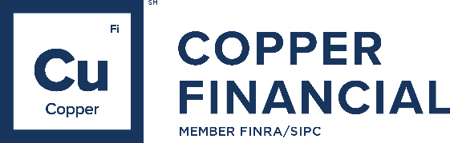
Cash Sweep

Rate List

Bank Deposit Sweep Program (BDSP)

Sweep Indicator (AIGI & IDPR) Current yield as of 1/6/2026

Tiers | Deposit Range | Rate
1 | $0 – $24,999 | .01%
2 | $25,000 – $49,999 | .03%
3 | $50,000 – $99,999 | .03%
4 | $100,000 – $249,999 | .03%
5 | $250,000 – $499,999 | .05%
6 | $500,000 – $749,999 | .15%
7 | $750,000 – $999,999 | .40%
8 | $1,000,000 – $1,499,999 | .75%
9 | $1,500,000 – $4,999,999 | .85%
10 | $5,000,000 – MAX | 1.25%

Insured Cash Account Program (ICAP)

Sweep Indicator (BDSL) Current yield as of 5/18/2026

Eligible Accounts | Rate | Monthly Per Account
Investment Advisory/fee-based IRAs accounts | 0.21% | $19.75
* Rate is net of monthly account fee. The monthly account fee is anticipated to be paid by participating Program Banks.

Securities and advisory services offered through Copper Financial Network, LLC (“Copper Financial”), Member FINRA/SIPC. Copper Financial is a SEC registered investment adviser. Products offered through Copper Financial: are not NCUA/NCUSIF or otherwise federally insured, are not guarantees or obligations of the credit union, and may involve investment risk including possible loss of principal. Copper Financial is a wholly-owned subsidiary of CommunityAmerica Federal Credit Union.

Securities and investment advisory services are offered through the firms: Osaic Wealth, Inc. and Osaic Institutions, Inc., broker-dealers, registered investment advisers, and members of FINRA and SIPC. Securities are offered through Osaic Services, Inc. and Ladenburg Thalmann & Co., broker-dealers and members of FINRA and SIPC. Advisory services are offered through Ladenburg Thalmann Asset Management, Inc., Osaic Advisory Services, LLC. and CW Advisors, LLC., registered investment advisers. Advisory programs offered by Osaic Wealth, Inc. are sponsored by VISION2020 Wealth Management Corp., an affiliated registered investment adviser.
© Osaic, Inc. • osaic.com 05/26 5852465

